Student’s name | …………………………………………………….…… | Grade | 6
Subject | Computer | Week No. | 11
Lesson Title | Cyber Security | Unit
Worksheet No. ( 11 )

Question A: write the correct name of each part.

Firewall | Hacker | Server
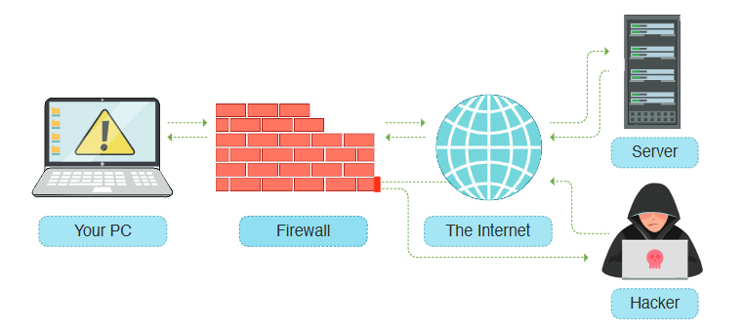
Good Luck
………………
………………
………………

